**WEEK-01(UNIX COMMANDS):**

Assignment: Implement the unix commands cat, split, sort, cd, comm, cmp, head, tail along with the complete list of options.

1. cat command

* Creating a new file :- We can create a new file with contents in it using the cat command in the specific directory specified. To end writing into the file press Ctrl+D.

Command used: cat > filename

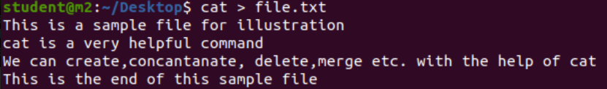

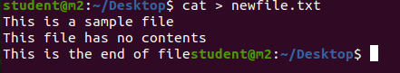

* Display the contents of the file :-

Command used: cat filename

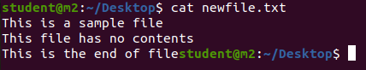

* Display line numbers along with the file content:-

Command used: cat -n filename

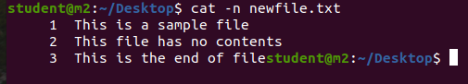

.

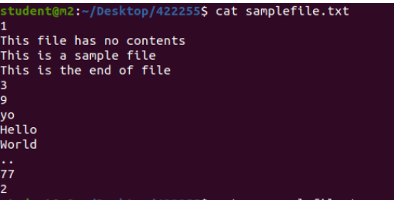

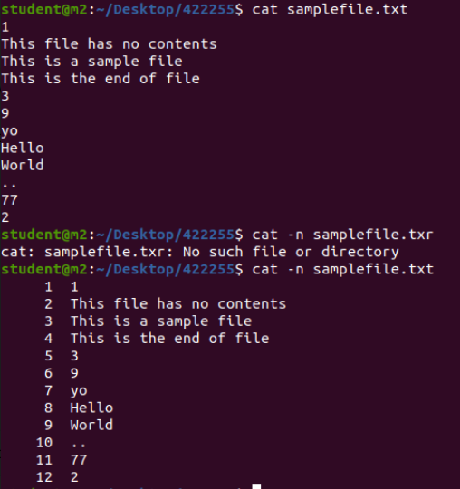

* Display the content of multiple files:-

Command used: cat file1 file2

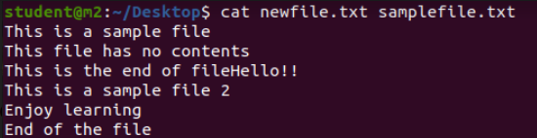

* Concatenate files and display the result:

cat file1 file2 > outputfile

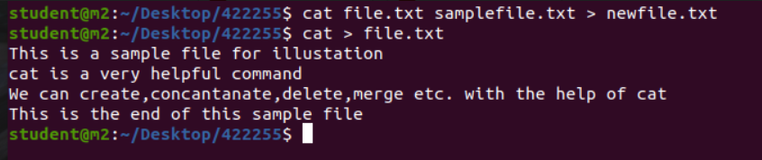

* Display non-printing characters (show tabs as ^I, and end lines with $):

Command used: cat -v filename

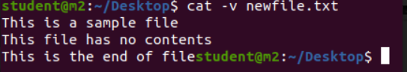

* Display contents with line breaks as "$" at the end of each line:

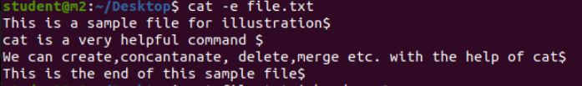

* Display the content of a file with a specified number of lines:

Command used: cat filename | head -n <num_lines>

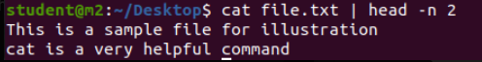

2. Split commands:

The **split** command in Unix is used to split a file into smaller parts. Here are some common options:

* Split a file into pieces with a specified number of lines:

Command used: split -l <lines_per_file> filename



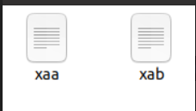

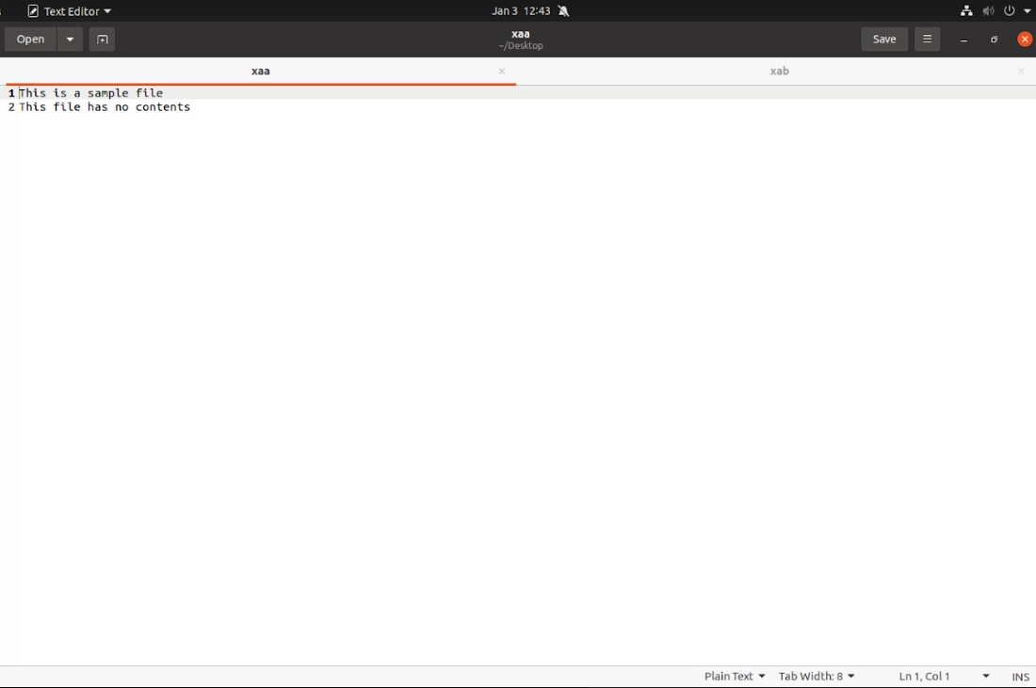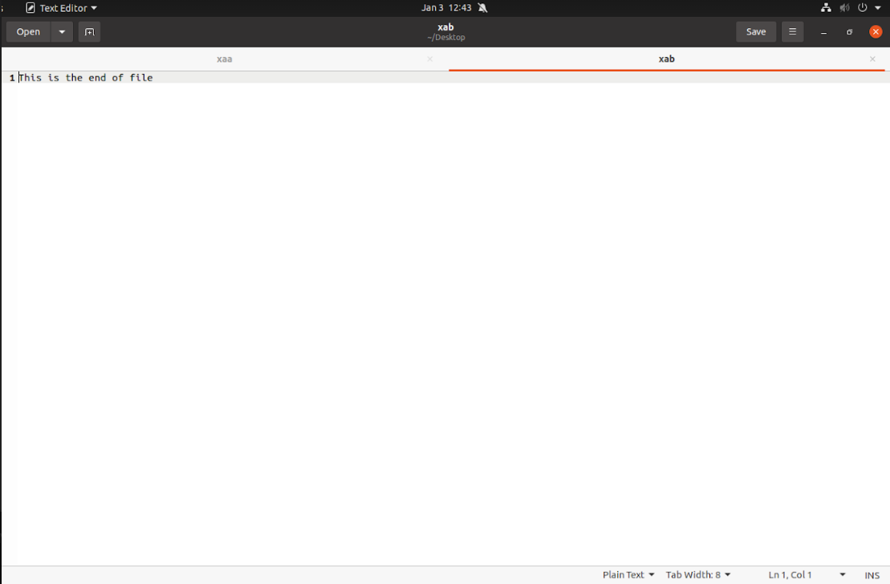

* Split a file into pieces with a specified number of bytes:

Command used: split -b <size_per_file> filename



 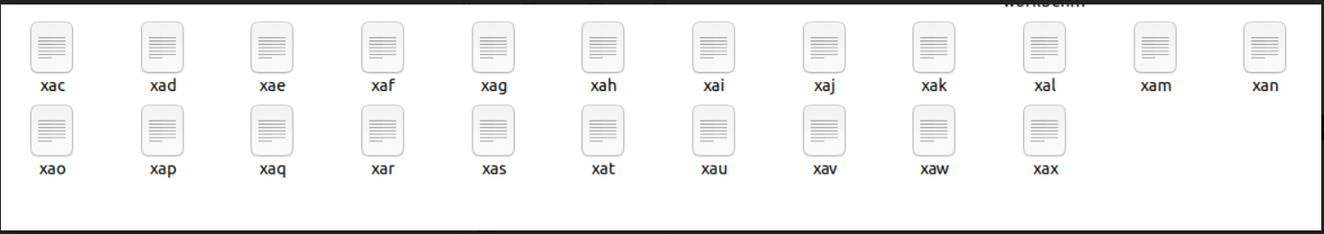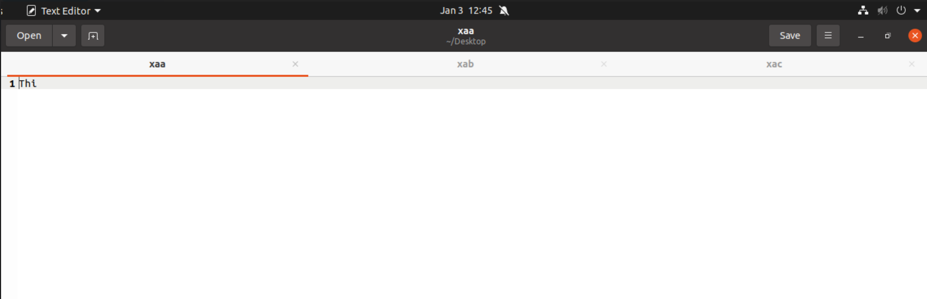

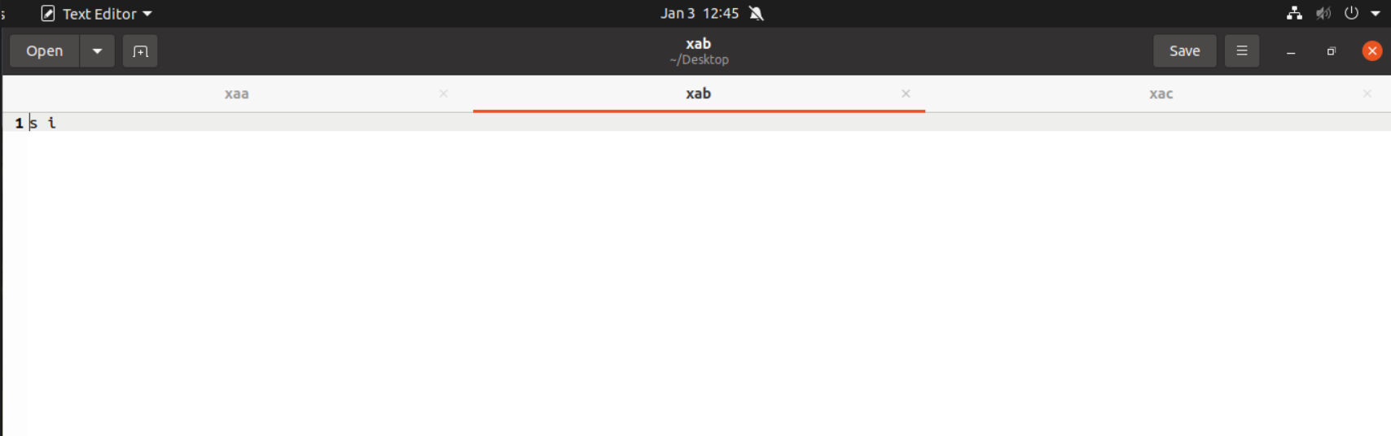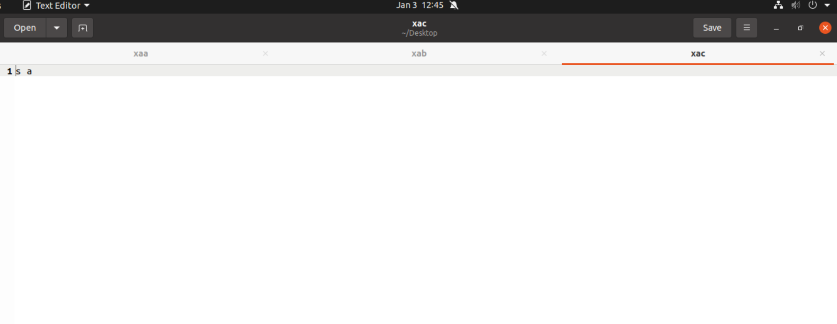

* Split a file into a specified number of equal-sized parts:

Command used: split -n <number_of_parts> filename



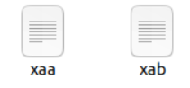

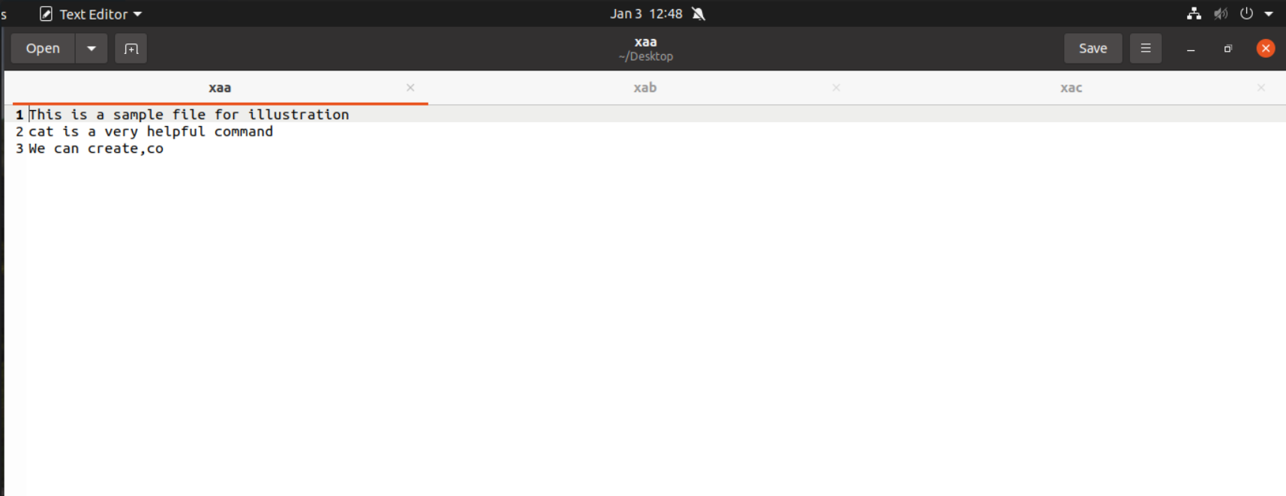

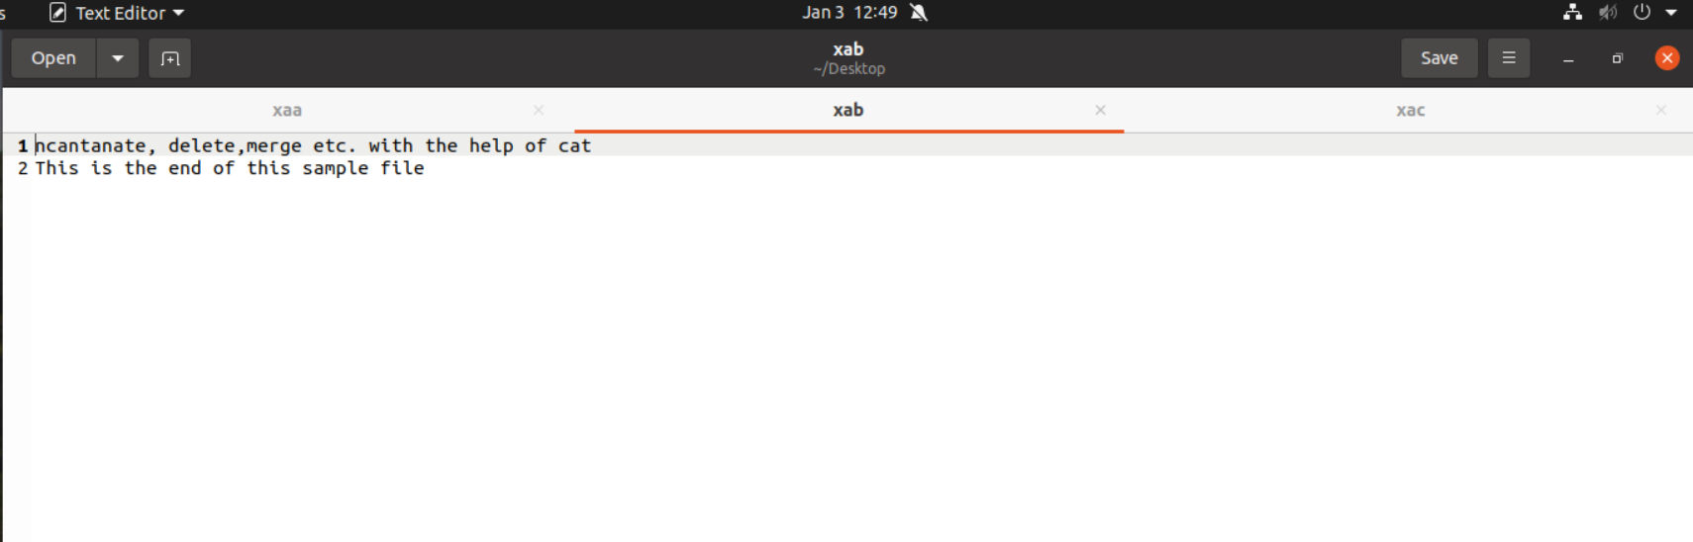

3. Sorting commands:

* Sort a file alphabetically:

Command used: sort filename



* Sort a file numerically:

Command used: sort -n filename

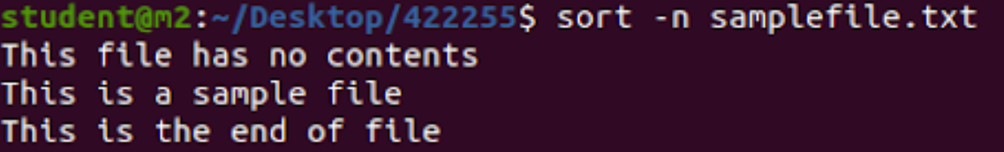

* Sort a file in reverse order:

Command used: sort -r filename

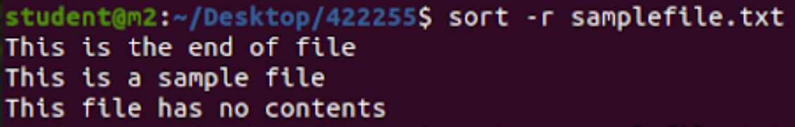

* Sort a file and remove duplicate lines:

Command used: sort -u filename

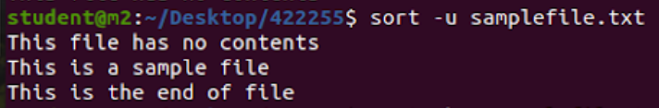

* Sort a file based on a specific column (using space as the delimiter):

Command used: sort -k <column_number> filename

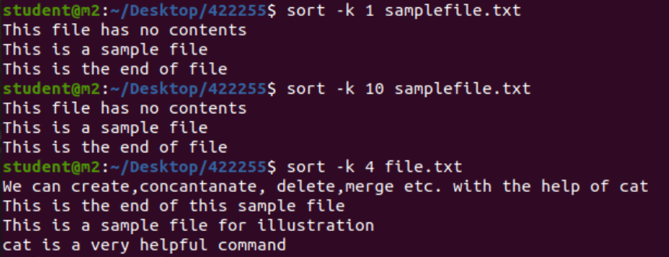

* Sort a file in a case-insensitive manner:

Command used: sort -f filename

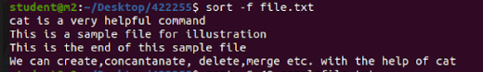

* Sort lines in memory for faster sorting:

Command used: sort -S <memory_size> filename

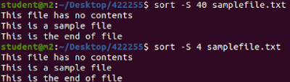

* Sort based on the month abbreviation (e.g., Jan, Feb, Mar):

Command used: sort -M filename

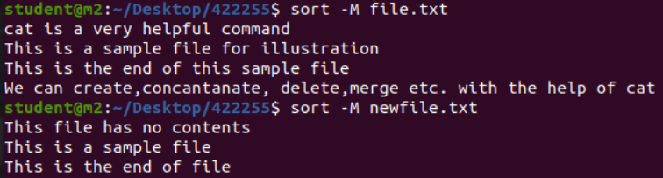



4. cd Commands:

The cd command in Unix is used to change the current working directory. Here are some common uses:

* Change to a specific directory:

Command used: cd /path/to/directory



* Change to the home directory:

Command used: cd



* Change to the previous directory:

Command used: cd -

* Move up one directory (parent directory):

Command used: cd ..



* Move up two directories:

Command used: cd ../..



* Move to the root directory:

Command used: cd /



* Change to the user's home directory:

Command used: cd ~username



* Change to a directory with spaces in the name (use quotes):

Command used: cd "directory with spaces"

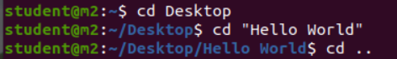

5. comm command:

The comm command is used to compare two sorted files line by line. Here are some common options:

* Basic usage:

Command used: comm file1 file2

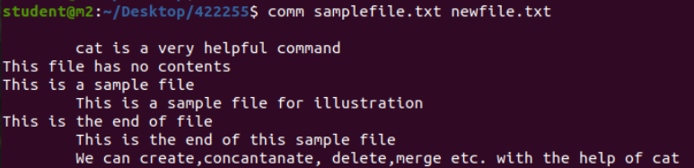

* This displays lines that are unique to file1, unique to file2, and common to both.
* Suppress output of lines unique to file1:

Command used: comm -1 file1 file2

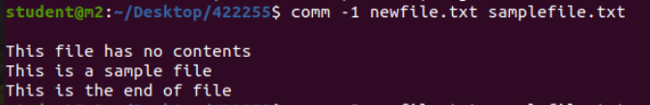

* Suppress output of lines unique to file2:

Command used: comm -2 file1 file2

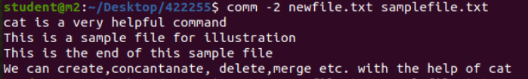

* Suppress common lines output:

Command used: comm -3 file1 file2

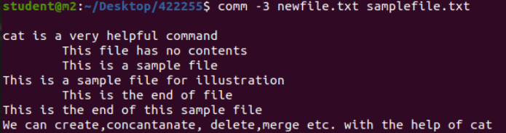

6. cmp command:

* Compares two files byte by byte and displays the first mismatch.

Command used: cmp file1 file2



7. head command:

* Displays the first few lines of a file.

Command used: head filename

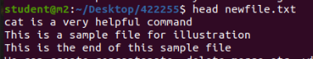

* Display a specific number of lines:

Command used: head -n 10 filename

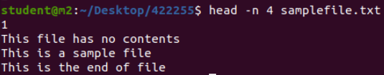

8. tail command:

* Displays the last few lines of a file.

Command used: tail filename

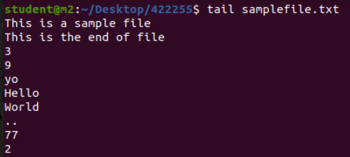

* Display a specific number of lines:

Command used: tail -n 10 filename

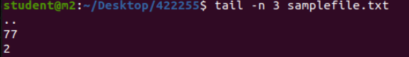

* Follow the growth of a file (similar to tail -f):

Command used: tail -f filename

